## **Objectives**

* Explain various ways of conditional rendering
* Explain how to render multiple components
* Define list component
* Explain about keys in React applications
* Explain how to extract components with keys
* Explain React Map, map() function

In this hands-on lab, you will learn how to:

* Implement conditional rendering in React applications

## **Prerequisites**

The following is required to complete this hands-on lab:

* Node.js
* NPM
* Visual Studio Code

## **Notes**

Estimated time to complete this lab: **60 minutes.**

Create a React App named “bloggerapp” in with 3 components.

1. Book Details
2. Blog Details
3. Course Details

Implement this with as many ways possible of Conditional Rendering.

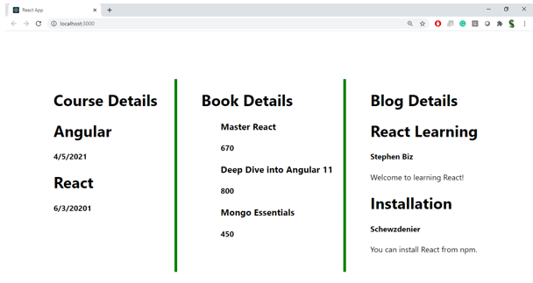

**Hint:**

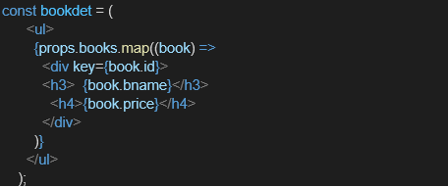

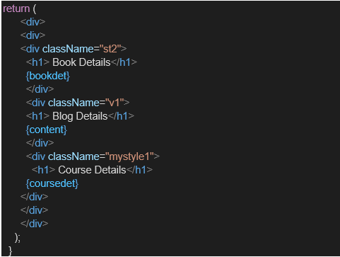

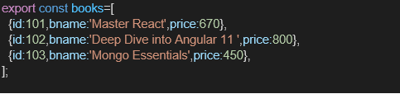

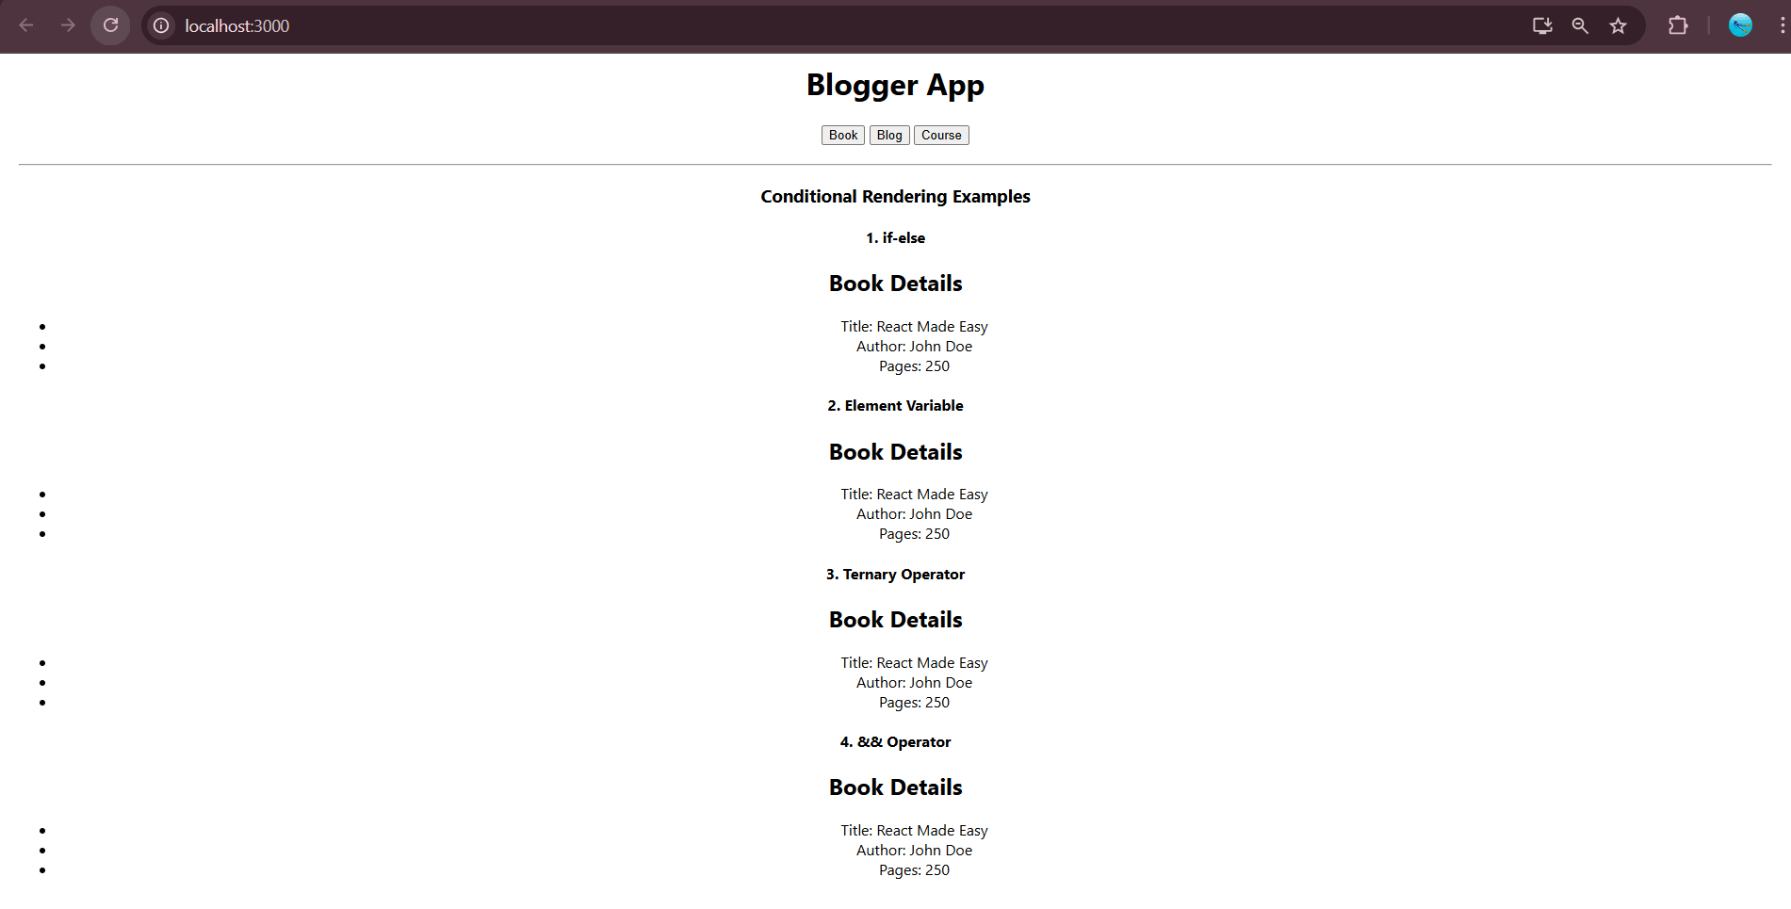

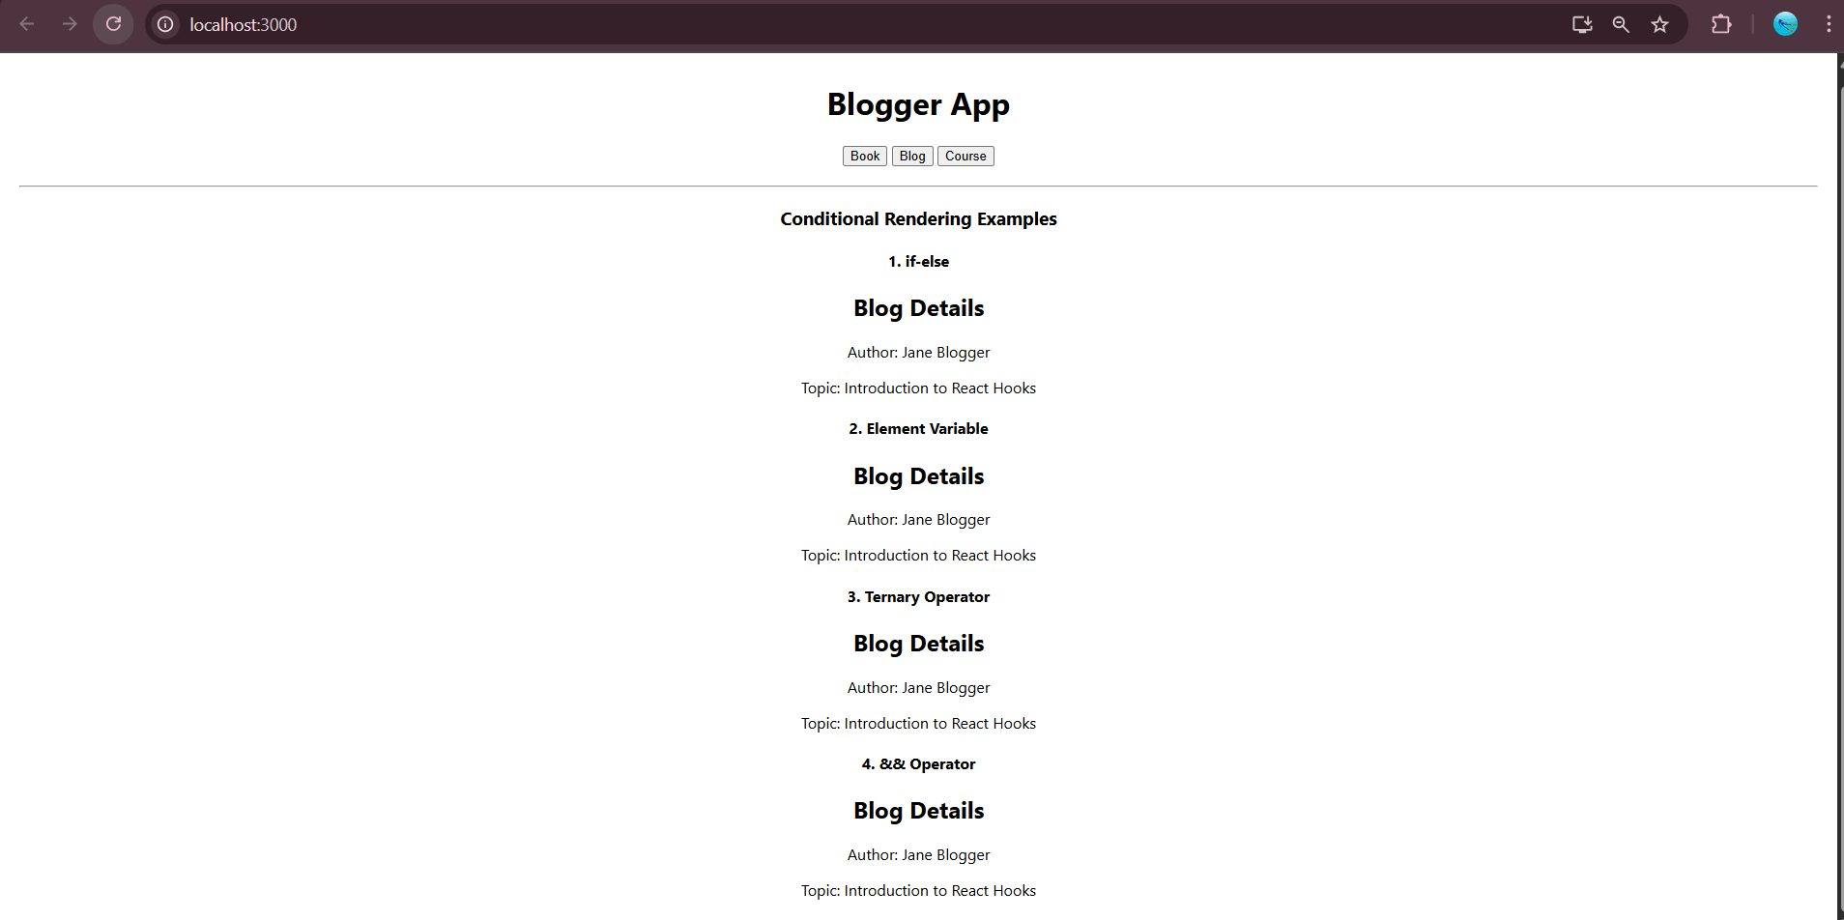

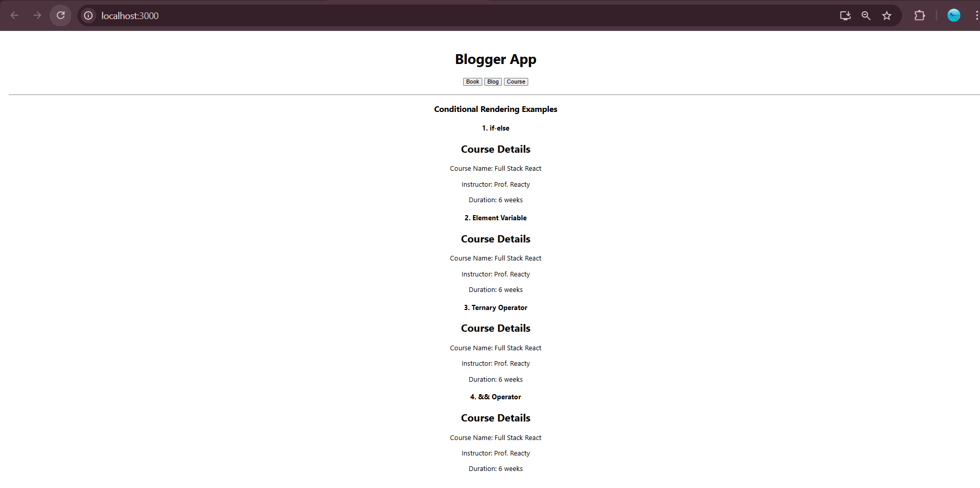

BookDetails.js

import React from 'react';

function BookDetails() {

return (

<div>

<h2>Book Details</h2>

<ul>

<li>Title: React Made Easy</li>

<li>Author: John Doe</li>

<li>Pages: 250</li>

</ul>

</div>

);

}

export default BookDetails;

BlogDetails.js

import React from 'react';

function BlogDetails() {

return (

<div>

<h2>Blog Details</h2>

<p>Author: Jane Blogger</p>

<p>Topic: Introduction to React Hooks</p>

</div>

);

}

export default BlogDetails;

CourseDetails.js

import React from 'react';

function CourseDetails() {

return (

<div>

<h2>Course Details</h2>

<p>Course Name: Full Stack React</p>

<p>Instructor: Prof. Reacty</p>

<p>Duration: 6 weeks</p>

</div>

);

}

export default CourseDetails;